How to Confirm Your Attendance with no balance due

- Log-in to your myRedDragon account
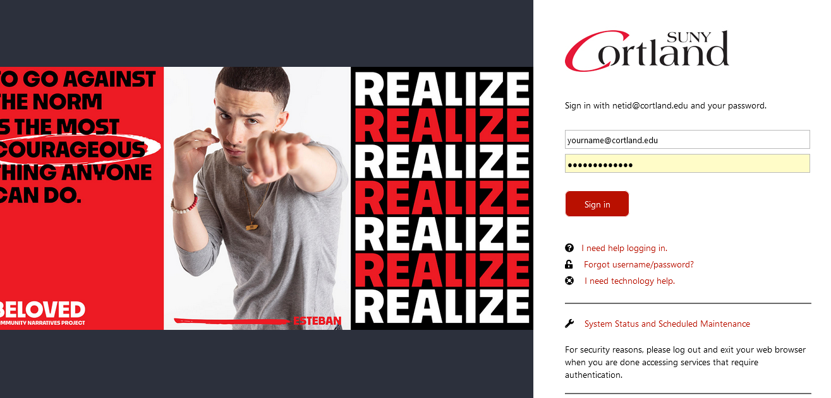

- Select the Student tab (your home page may view slightly different)
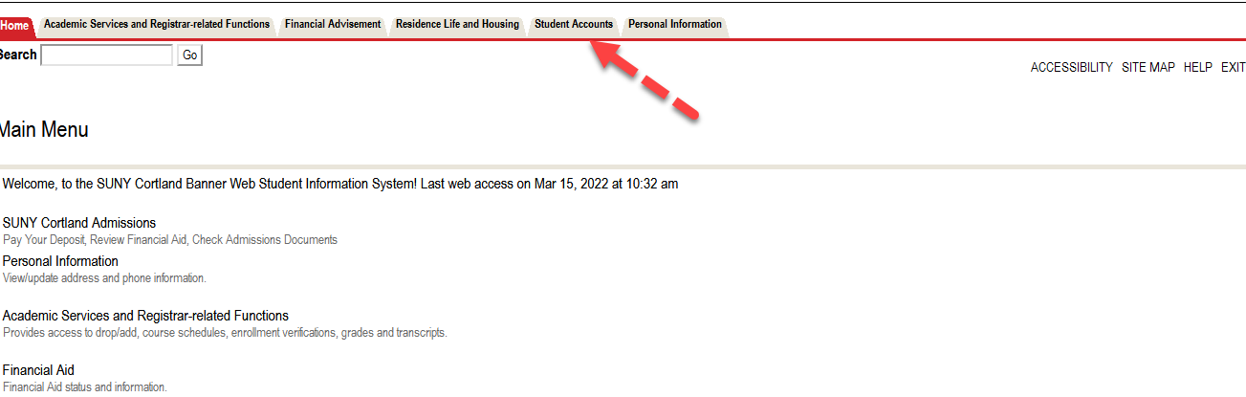

- Select Access Online Account
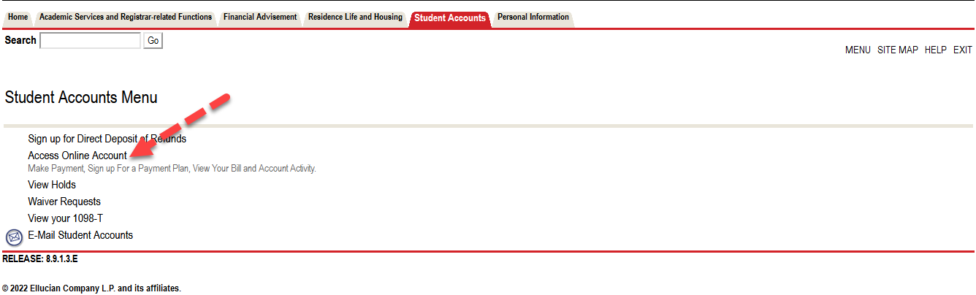

- Select term to confirm attendance
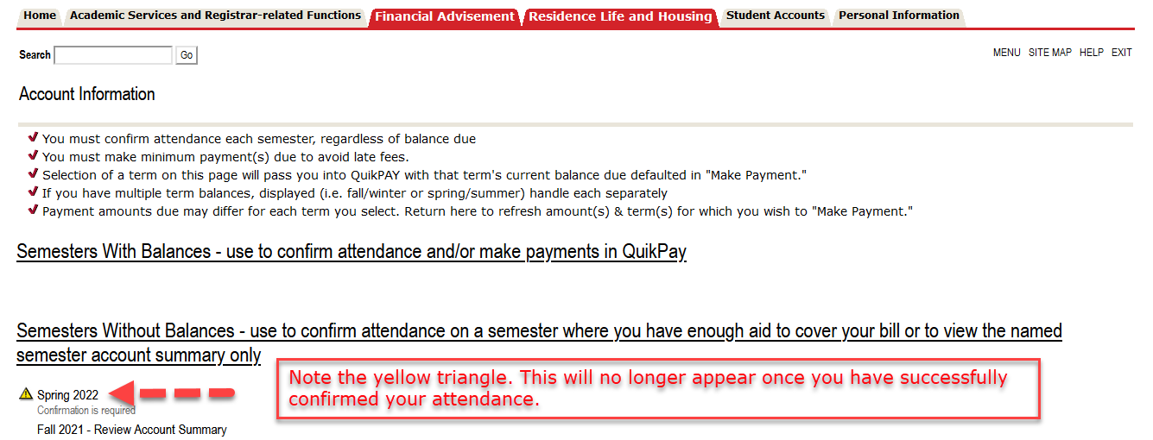

- Review your account summary and select “Accept/Pay or Decline.” All changes made to your student account will appear here in real time.
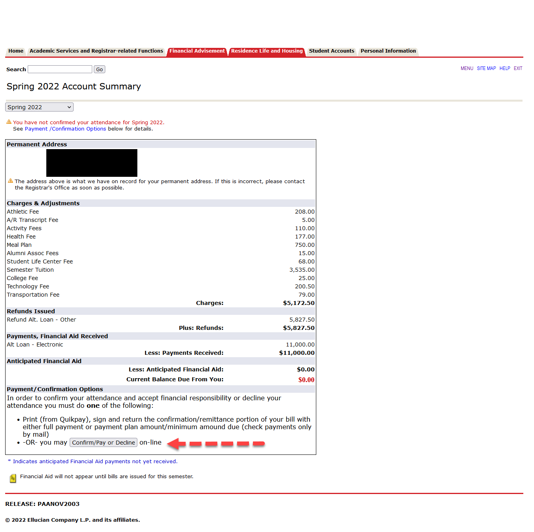
- Review verbiage, select “Accept” then “Continue” near the bottom of the page.
